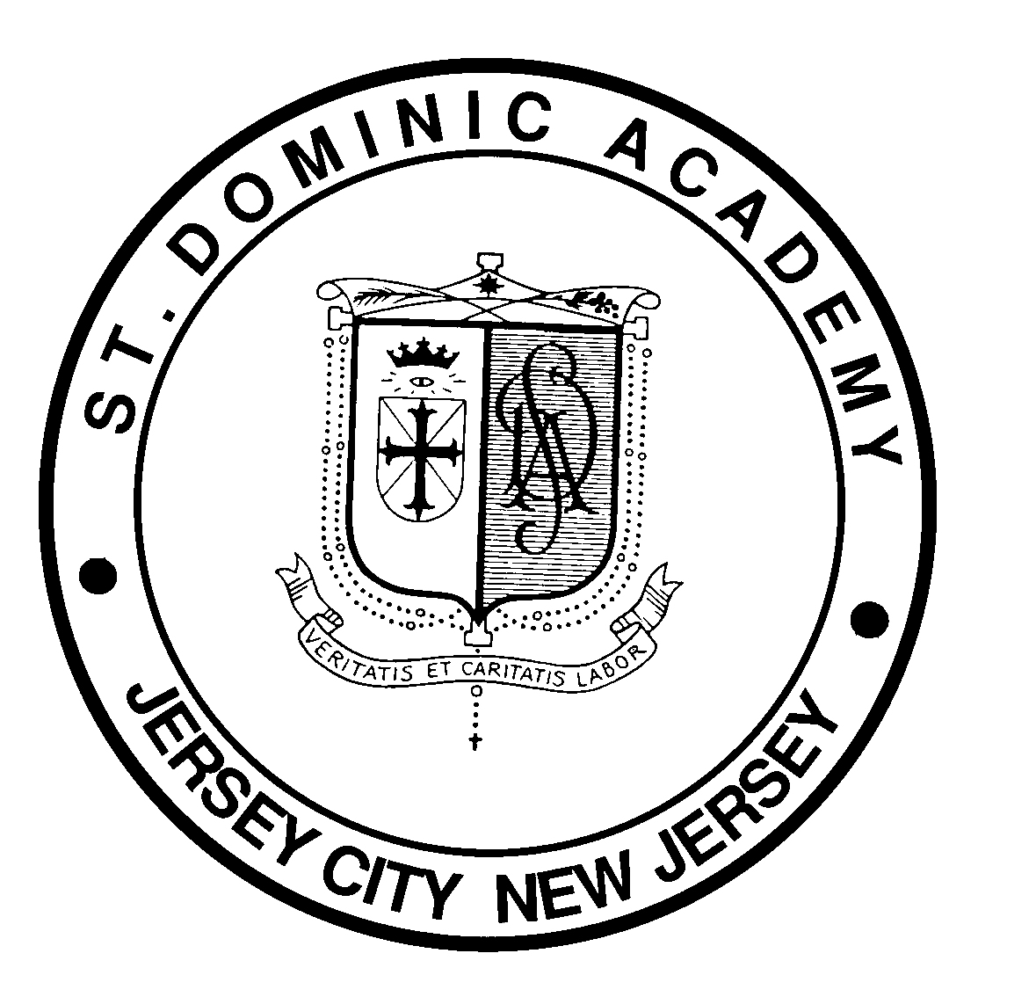
Monday
April 13th – 9:00 am
Lincoln Park
in Jersey City, NJ
22nd Annual
2020
Spring Invitational

2

It is a pleasure to again take this opportunity to invite you to an exciting meet that is being sponsored by the Athletic Department of Saint Dominic Academy. The 22nd Annual SDA Track & Field Spring Invitational will be held, rain or shine, in Lincoln Park’s beautiful new and lightning-fast track & field facility. This year for we will again feature FAT.
We hope you will join us for a great day of events for all members of your team as you start your season. As always, we have a wide variety of events at a reasonable entry cost ($325 per team / $600 for a school bringing both boys and girls). These fees allow for unlimited events. If we have sufficient entries, we will award six (6) medals in ALL events and ALL divisions, as well as award our custom “Champion” T-shirts to the winners of each event.
In an effort to increase our ability to provide you with a smooth running and efficient meet, we ask that you return your entry form no later than Friday, 3 April 2020. Please join us for a great day of Track & Field for all members of your team. We wish you continued success throughout the year and thank you for your support, including the legions of you who joined us in the Jersey City Armory for our winter series.
Order of Events

FIELD EVENTS | RUNNING EVENTS
High Jump (FB, SB, VB, FG, SG, VG) | Intermediate Hurdles - Girls First
Long Jump (FG, SG, VG, FB, SB, VB) | 3200m Relay
Shot Put (FB, SB, VB, FG, SG, VG) | High Hurdles
Discus (VG, SG, FG, VB, SB, FB) | 100m Dash
Javelin (VB, SB, FB, VG, SG, FG) | 1600m Run
 | 400m Relay
 | 400m Dash
 | 800m Run
 | 200 Dash
 | 3200m Run
 | 1600m Relay

The order of running events will be FB, FG, SB, SG, VB, and VG. All running events will be finals on time, except for the 100m dashes and the High Hurdles. Divisions will be combined where the entry is low; however, separate awards will be given. National Federation Rules will be in effect.
NJ MILESPLIT: Team Roster entry by Thursday, April 9th

22nd Annual
2020
Spring Invitational
Monday
April 13th – 9:00 am
Lincoln Park
in Jersey City, NJ

ENTRY FORM
Our school plans to attend the 22nd Annual SDA Spring Invitational on Monday, April 13, 2020 in Lincoln Park. We understand that the meet will be held rain or shine; therefore, no refunds will be possible should our team fail to attend. We are committing to an entry fee, NOT a participation fee. NOTE: The javelin event will be held on an adjoining field, barring the existence of circumstances beyond our control that may force cancellation.

We are entering the following divisions: Boys / Girls / Both
School: _____________________________________________________________________________________
Address: ____________________________________________________________________________________
Telephone / ext.: _________________________________ Email: _____________________________________

Coach’s Signature: ________________________________________ Phone: ____________________________
A.D.’s Signature: __________________________________________ Date: _____________________________

Fees: $325 per team or $600 if you have both boys and girls.
Please adhere to our deadline of Friday, April 3, 2020. Please provide a non-binding estimate of how many event participants cards you will need so we can better prepare for your arrival. Number of cards: _______
Please make checks payable to: Saint Dominic Academy
USPS Mail (PO/Check) and entries to:
John E. Nagel, Meet Director – 10 Cherry Street, Jersey City, NJ 07305 Cell: (201) 401-7394
Entries can also be e mailed to: jnagel@stdominicacad.com

